Pearl Ayem - 34404160

**UBC ATSC 303 Lab 10**

**Eddy Correlation and Sensible and Latent Turbulent Heat Fluxes**

**Part 1**

1. Timeseries of the raw data

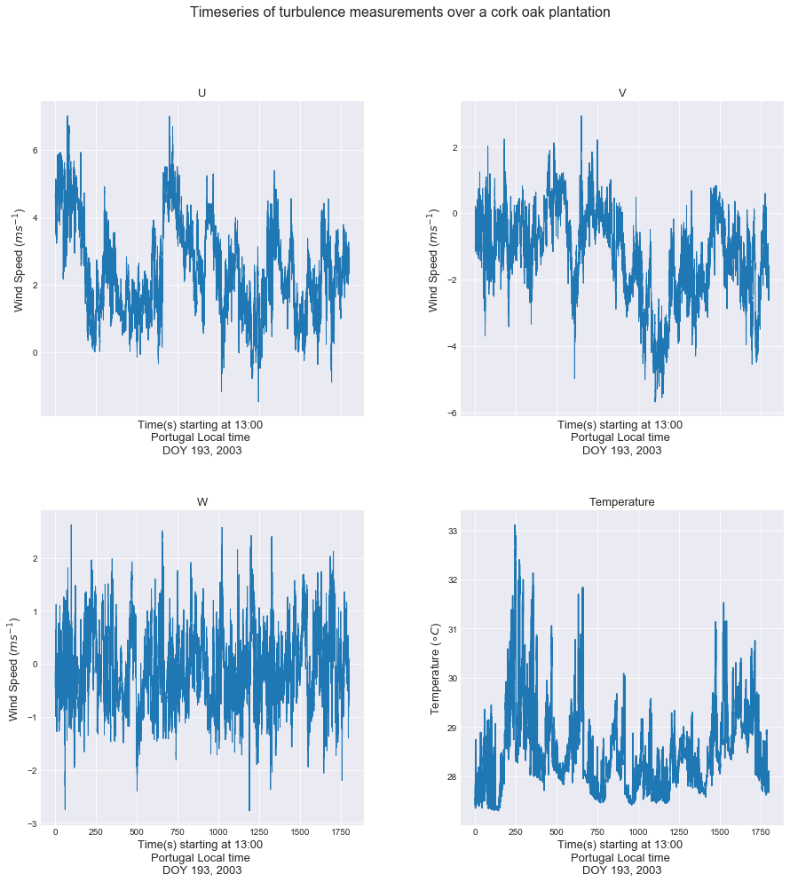

1. Mean values are as follows:

Average U is 2.4259 ms-1

Average V is -1.2518 ms-1

Average W is -0.0967 ms-1

Average TEMP is 28.4918 ℃

1. Perturbation timeseries

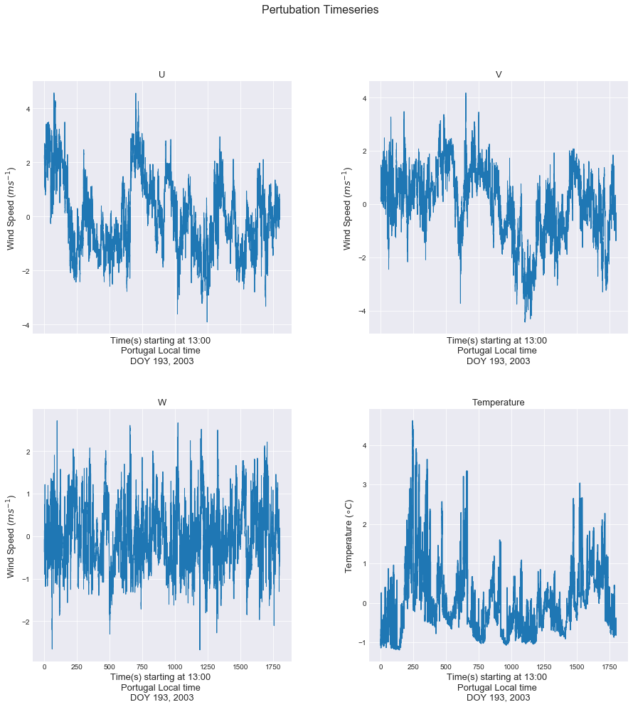

1. Mean value of each perturbation is 0 because the perturbations itself are like de-trending and setting the mean to 0. So the mean of that value is thus also 0.
2. Variance of U is 1.8589 m2 s-2

Variance of V is 1.7282 m2 s-2

Variance of W is 0.4779 m2 s-2

Variance of T is 0.7337℃2

The turbulence is *not* isotropic since $σ_{u}^{2} ≠ σ_{v}^{2} ≠ σ_{w}^{2}$

$TKE= \frac{1}{2}*\left(σ_{u}^{2}+σ_{v}^{2}+σ_{w}^{2}\right)$

TKE is 2.0325 m2 s-2

1. Turbulent Intensity of U is 0.562

Turbulent Intensity of V is -1.0502

Turbulent Intensity of W is -7.1471

Turbulent Intensity of T is 0.0301

The turbulent intensity is greatest in the W direction.

1. Average U'W' is -0.2848 m2 s-2 🡪 Reynold’s Stress/ Turbulent momentum flux

Average V'W' is 0.1021 m2 s-2 🡪 Turbulent momentum flux

Average T'W' is 0.3086 C m s-1 🡪 Kinematic vertical heat flux

1. Sensible Heat Flux is 310.0416 Wm-2

Stress is 0.2848 Pa (Using Stull 18.38c) = 0.0002848 kPa.

1. 775.1041 Wm-2
2. 0.31 mm per day

$0=F^{*}+F_{H}+F_{E}-F_{G}=$ $$0=F^{*}+310.0416+775.1041-0.1F^{*} \\ 0.9F^{*}=- 1085.1457 \\ F^{*}= -1205.7174 Wm^{-2}$$

Part 2

1. Average mixing ratios
   1. At 2m =-637.4854
   2. At 10m =-636.9760
2. Using Stull 3.57,3.58 and 3.59:

Average Sensible Heat Flux is -22.0312

Average Latent Heat Flux is -9.6223

1. Discuss the significance of the values that you find in question (2), in terms of magnitude and sign.
2. Why do you think half an hour of data was used for this method? /2